SCIENCE PRACTICAL ASSESSMENT:
COMPLETE INVESTIGATION ASSESSMENT RUBRICS

Criterion D: Scientific Enquiry
The IB says to get top marks…

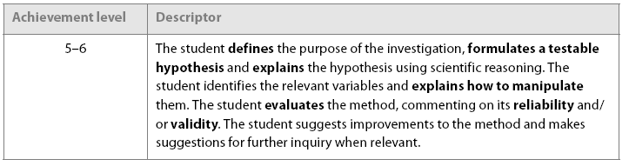

Our rubric: make sure you have completed all of the tasks at each level if you want to succeed!
ASPECT | 0 | 1-2 | 3-4 | 5-6
AIM:  identifying the problem | Not completed to a standard met by the descriptors above. | Aim attempted, though may not be clear, or may not identify the variables. | Good aim, though may be lacking in detail or reference to variables.  Independent and dependent variables stated. | Clear aim allows the reader to immediately understand the point of the investigation.  Independent and dependent variables clearly stated, with units.
HYPOTHESIS (1):  prediction | Not completed to a standard met by the descriptors above. | Very basic prediction made, with no mention of type of relationship expected. | Clear prediction made, with an attempt at defining the type of relationship expected. | Clear prediction made, with relationship between variables predicted and quantifiable where appropriate.
HYPOTHESIS (2):  Scientific background | Not completed to a standard met by the descriptors above. | Very basic reasons given for the prediction, with little or no depth. Hypothesis may be difficult to test. | Good explanation of theory behind the prediction, though some minor errors may be apparent, or lacking in depth. | Supporting Science is sound and explains all aspects of the prediction. Hypothesis is clearly testable.
MATERIALS: | Not completed to a standard met by the descriptors above. | Very basic materials list produced, some of those required may not be mentioned. | Full list produced, mostly with sizes/quantities stated. | Full and complete materials list, with quantities and dimensions of all equipment stated.
METHOD (1):  collecting data | Not completed to a standard met by the descriptors above. | Very basic method.  No detail of units, number of data points or measures taken to ensure enough data are collected. | Method gives enough data for testing the hypothesis, with units. Details of steps taken to ensure accuracy may be missing. | Method allows for collection of sufficient data points, stating units to be used and techniques for accuracy.
METHOD (2):  controlled variables | Not completed to a standard met by the descriptors above. | Fewer than 3 variables controlled. Method used my or may not be effective. | 3 variables that may affect results stated, with some steps given to minimize their effects. | Clear method given to control at least 3 variables that may affect results (table produced?)
METHOD (3):  reliability |  | Little thought given to reliability of results or repetition of samples. | Some steps taken to reduce sampling or testing errors. | Method clearly stated how reliability of the data produced will be ensured.
METHOD (4):  Diagram |  | Diagram is minimal, scruffy, unlabeled or inaccurate. | Good basic diagram of some stages of investigation, though may lack some accuracy. | Clear, large, labeled diagram of critical stages of investigation given.
METHOD (5):  data manipulation |  | - | Type of graph or calculations stated. | Type of graph/statistical method stated and explained.
EVALUATION (1):  limitations of method |  | Evaluation attempted, though may focus on limitations outside the method. | Limitations of method suggested, with some reasons given. | Limitations of method recognized and explained, with examples given from collected data.
EVALUATION (2):  suggestions for improvement |  | Basic or unrealistic suggestions made, with little basis. | Some valid suggestions for improvements made, which may or may not be connected to collected data. | Clear, achievable improvements suggested, based on results collected.

SCIENCE PRACTICAL ASSESSMENT:
COMPLETE INVESTIGATION ASSESSMENT RUBRICS

Criterion E: Data Processing
The IB says to get top marks…

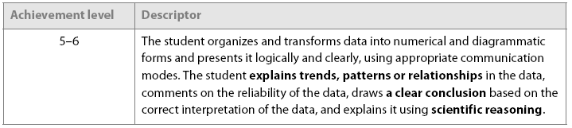
Our rubric: make sure you have completed all the tasks if you want to succeed!
ASPECT | 0 | 1-2 | 3-4 | 5-6
RAW DATA:  Tables or charts | Not completed to a standard met by the descriptors above. | Scruffy, poorly labeled results table produced. | Results presented in a clear, large, labeled table. | Results presented in a clear, large, labeled and titled table or chart, with units given.
TRANSFORMATION OF DATA | Not completed to a standard met by the descriptors above. | Some inconsistent data transformation, which may or may not be useful. | Data converted into averages or frequencies, and restated in the table. | Data transformed into the most appropriate form for later use. Anomalies noted and removed from calculations.
CHOICE OF PRESENTATION:  Graphs, diagrams, images | Not completed to a standard met by the descriptors above. | Basic graph or chart produced, which may not be the appropriate choice. | - | Appropriate graph, diagram or other form chosen to present data. Adds value to the write-up and clarifies results.
ACCURACY OF DATA PRESENTATION | Not completed to a standard met by the descriptors above. | Graph or diagram lack labels, accuracy or is otherwise seriously flawed. | Generally good presentation, though may lack some labels or units. | Clear, large, labeled and titled, with units given and results presented accurately. Plotting is precise and tidy.
RESULTS (1):  statement of results. | Not completed to a standard met by the descriptors above. | Very basic, possibly inaccurate statement of data given. | Overall trend in data given. | Trends in data identified and stated, with supporting results. Changes in the trend identified. Anomalies identified.
RESULTS (2):  trends, patterns and relationships | Not completed to a standard met by the descriptors above. | - | - | Trends, patterns and relationships identified, with proper terminology and defined limits based on collected data.
CONCLUSION (1):  reasoning |  | May or may not match collected data, lacks in depth and scientific explanation. | Trends explained using scientific theory, though some relationships may be forgotten or inappropriately interpreted. | All trends in data explained accurately using scientific theory and supported with examples from collected data.
CONCLUSION (2):  relationship with hypothesis |  | Simple, unsupported statement, such as ‘My hypothesis was right.’ | Hypothesis accepted or rejected, based on collected results. | Hypothesis accepted or rejected, based on collected results and supported with theory. Rejected hypothesis is modified with reasons.
CONCLUSION (3):  further study |  | Simple or unrelated idea given for areas of further study. | One or more appropriate ideas given for areas or further study, based on the conclusion of this investigation. | One or more appropriate ideas given for areas or further study, based on the conclusion of this investigation. Variables stated, and method outlined.

SCIENCE PRACTICAL ASSESSMENT:
COMPLETE INVESTIGATION ASSESSMENT RUBRICS

Criterion F: Attitudes in Science

The IB says to get top marks…

Our rubric: make sure you have completed all tasks to get the best possible marks!
ASPECT | 0 | 1-2 | 3-4 | 5-6
INDEPENDENCE | Not completed to a standard met by the descriptors above. | Constant supervision needed and help given. | Generally independent, though some help from the teacher may be required. | Completely independent.
PRECISION AND SKILL | Not completed to a standard met by the descriptors above. | Equipment used inappropriately, with little regard for accuracy or precision. | Generally uses equipment appropriately, though some evidence may be apparent of lack of precision. | Steps taken to ensure precision of measurements taken. Equipment used appropriately.
SAFETY | Not completed to a standard met by the descriptors above. | Requires guidance or monitoring to ensure own safety and safety of others. | Generally safe, with good regard for lab rules. May make minor errors in judgement. | Very safe, uses all protective equipment necessary, ensures safety of other members of the group.
RESPONSIBILITY | Not completed to a standard met by the descriptors above. | Work area is messy or disorganized. Materials not returned to storage areas or may be broken or missing. Handling of live resources may be immature or inappropriate. | Work area is generally kept clean and organized, though may lack effort in clearing up. Live resources treated with respect and care. | Clean, organized work area, all equipment cleaned after use and returned. Live resources treated with care and respect. Environmental impact of the investigation considered.
TEAMWORK | Not completed to a standard met by the descriptors above. | Works poorly with others, or only under duress. | Works generally well with others, though some lack of fluidity of communication between the group may be evident. | Respects views of other team members, includes all in the decision making process, ensures safety of all, makes sure all have a complete set of data. Takes responsibility for errors.
ACADEMIC HONESTY |  | Only the most basic attempt at referencing, with no in-text citation. | Sources cited and referenced, though with some inaccuracy. | Sources are cited and referenced appropriately, using a standard method.

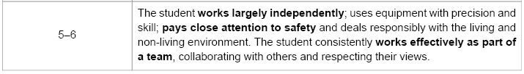
MYP SCIENCE PRACTICAL INVESTIGATION MARK SHEET (Criteria D, E, F).
Keep this document safely stuck in your notebook or file and refer to it each time you are assessed for these criteria.
CRITERION D | Score= |  | CRITERION E | Score= |  |  | CRITERION F | Score=
Aim |  |  | Raw data |  |  |  | Independence
Hypothesis (1) |  |  | Transformation |  |  |  | Precision/Skill
Hypothesis (2) |  |  | Choice of pres. |  |  |  | Safety
Materials |  |  | Accuracy of pres. |  |  |  | Responsibility
Method (1) |  |  | Results (1) |  |  |  | Teamwork
Method (2) |  |  | Results (2) |  |  |  | Ac. Honesty
Method (3) |  |  | Conclusion (1) |  |  |  | Notes:
Method (4) |  |  | Conclusion (2)
Method (5) |  |  | Conclusion (3)
Evaluation (1)
Evaluation (2)

Joshua Kennedy
Lisa Widjaja
19 Maret 2012

ETHANOIC ACID

Objective: The objective of this lab activity is to determine the concentration of ethanoic acid in a commercial vinegar sample by the method of standardization of a solution.

Research Question: Will the amount of NaOH needed so that the moles of NaOH solution and the vinegar the same increase if the concentration of vinegar in the solution is increased also?

Hypothesis: Regarding to the research question, we predict that the amount of NaOH needed to determine the moles of ethanoic acid in the solution will increase along with the concentration of vinegar in the solution, since the thicker the solution is, the concentration of the ethanoic acid will be increased too, and thus it will be for the NaOH solution to break down the solution and find the ethanoic acid.

Variables:
Independent: Volume of vinegar
Dependent: molarity of the vinegar, the concentration of ethanoic acid
Control:
- Volume of vinegar, since if we are using more vinegar, the concentration of ethanoic acid will increase (according to our hyphotesis)
- Amount of water used, since if more water is added, the vinegar will be less affectionate, thus reducing the concentration of the ethanoic acid.
- Amount of NaOH added to the solution, because if the amount of NaOH is incorrectly noted, everything will be for nothing.

Materials:

100 mL of Acetic Acid solution
±100 mL of distilled water for each trial
25 mL of phenolphthalein solution
±100 mL of NaOH solution for each trial, concentration = 0.5

Apparatus:
Pipette
250 mL Erlenmeyer flask x3
250 mL beaker x3
Droppers (to accurately drop the Phenolphthalein)
Buret
Funnel

Safety: It is recommended for students to wear protective goggles, since the NaOH solution is dangerous to the eyes. Lab coat and protective gloves are a must to this experiment, and must be worn at all time.

6. Method (step by step):

1. Pipette aliquot of vinegar into 250mL Erlenmeyer flask.
2. Dilute with distilled water to about 100 mL.
3. Add 2 drops of phenolphthalein solution.
4. Titrate with NaOH solution till the first color change.
5. Maintain the color so that it will not be too dark or too light.
6. Record the data
7. Repeat step 1-6

7. Data collection - table and mathematical equation(s) which you will use.

Trials | Amount of Vinegar used | Amount of Distilled Water used | Amount of solution before titrating | Amount of NaOH used | Amount of solution after titrating
1 | 3mL | 97mL | 100mL | 26 | 126
2 | 3mL | 97mL | 100mL | 25.5 | 125.5
3 | 3mL | 97mL | 100mL | 32 | 132

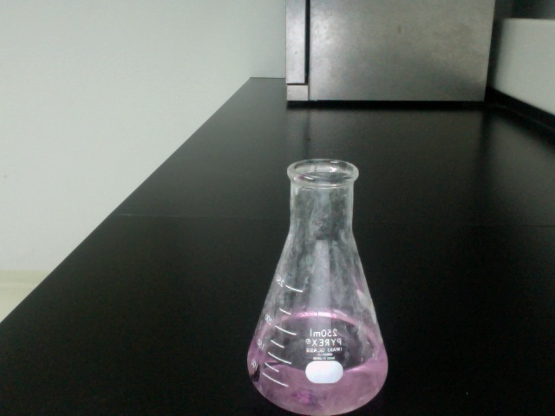
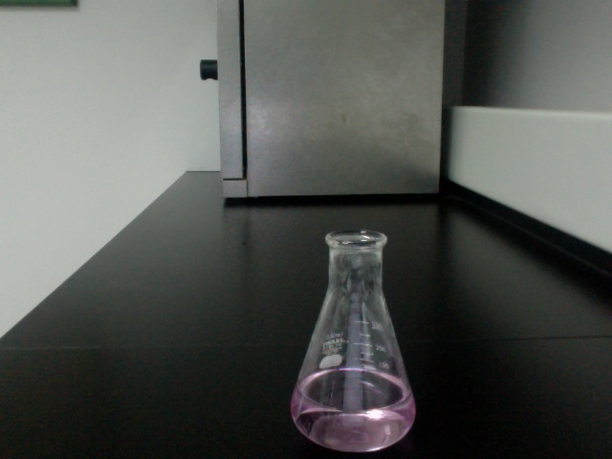
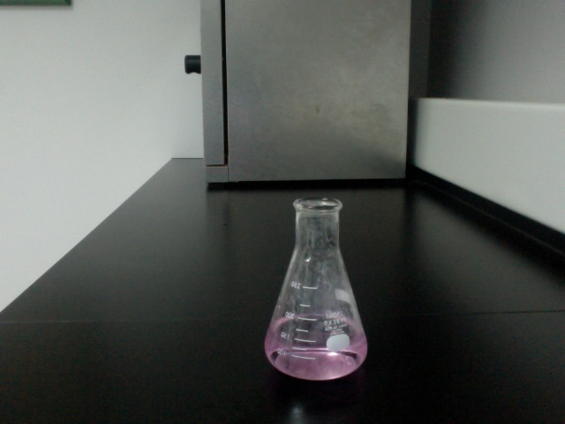

Trials | Amount of Vinegar used | Amount of Distilled Water used | Amount of solution before titrating | Amount of NaOH used | Amount of solution after titrating
1 | 5mL | 95mL | 100mL | 38mL | 138mL
2 | 5mL | 95mL | 100mL | 41mL | 141mL
3 | 5mL | 95mL | 100mL | 44mL | 144mL

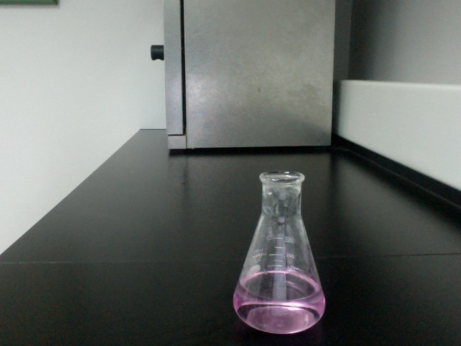
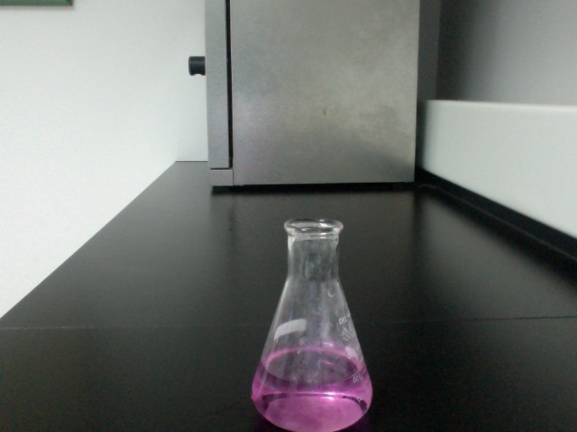
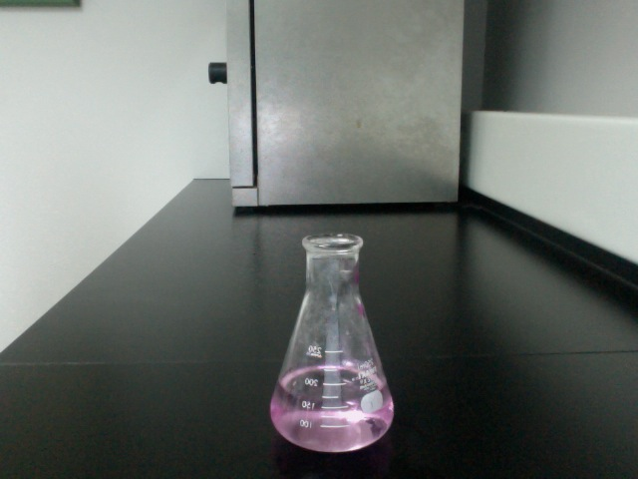

Trials |  | Amount of Vinegar used | Amount of Distilled Water used |  | Amount of solution before titrating |  | Amount of NaOH used |  | Amount of solution after titrating
1 | 7mL |  |  | 93mL |  | 100mL |  | 57mL |  | 157mL
2 | 7mL |  |  | 93mL |  | 100mL |  | 56mL |  | 156mL
3 | 7mL |  |  | 93mL |  | 100mL |  | 55mL |  | 155mL

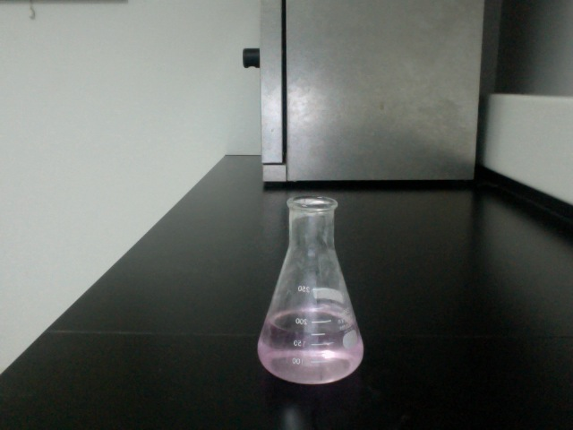
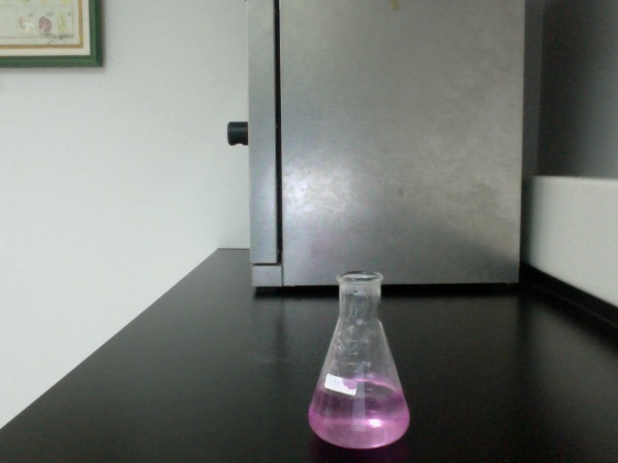
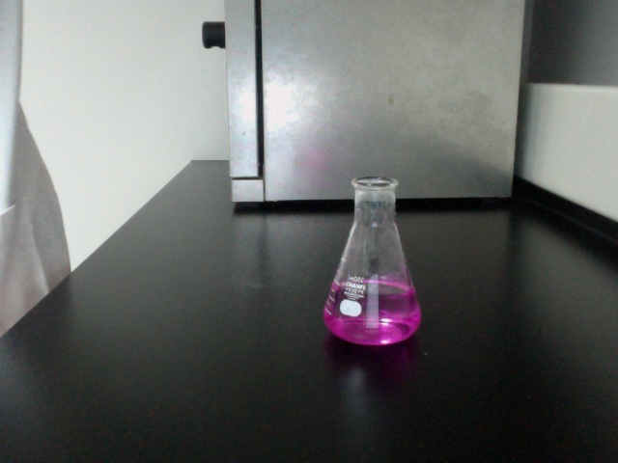

Trials | Amount of Vinegar used | Amount of Distilled Water used | Amount of solution before titrating | Amount of NaOH used | Amount of solution after titrating
1 | 8mL | 92mL | 100mL | 65mL | 165mL
2 | 8mL | 92mL | 100mL | 67mL | 167mL
3 | 8mL | 92mL | 100mL | 68mL | 168mL

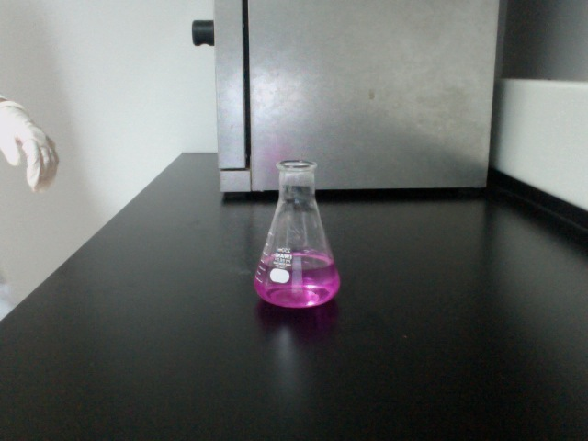
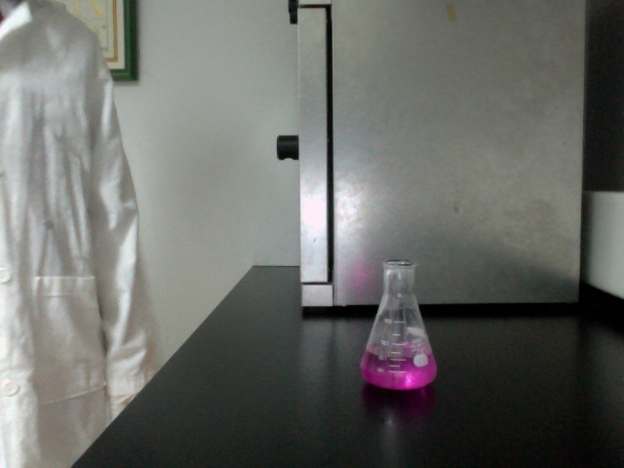
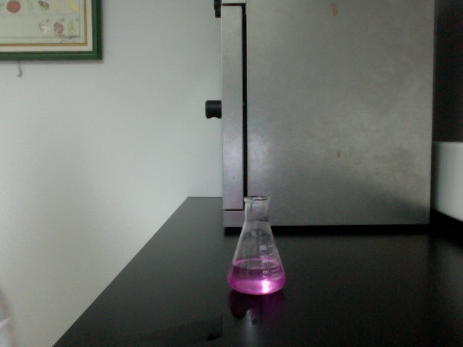

Trials | Amount of Vinegar used | Amount of Distilled Water used | Amount of solution before titrating | Amount of NaOH used | Amount of solution after titrating
1 | 9mL | 91mL | 100mL | 74mL | 174mL
2 | 9mL | 91mL | 100mL | 75mL | 175mL
3 | 9mL | 91mL | 100mL | 77mL | 177mL

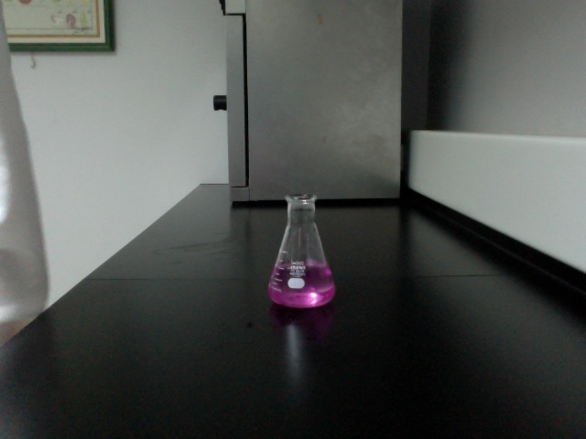
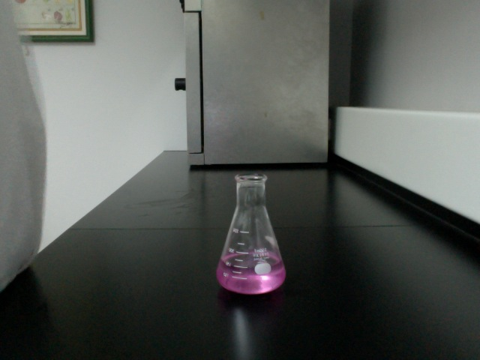
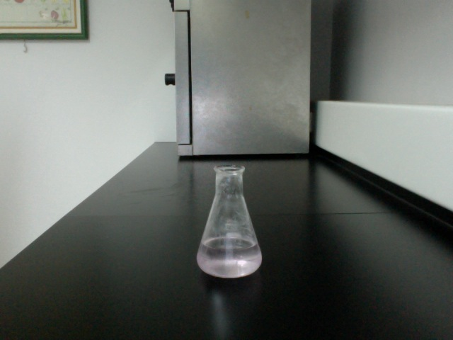

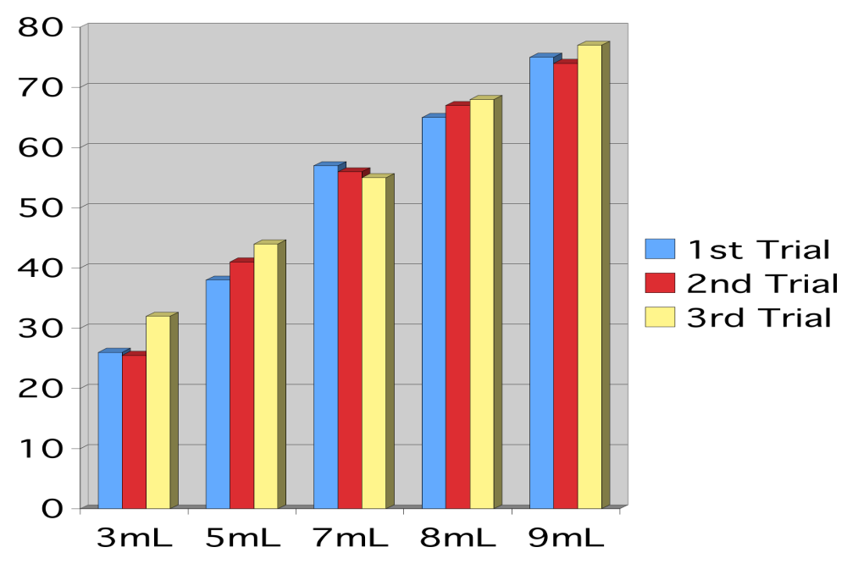

Neutralization reaction:
CH₃CO₂H + NaOH = H₂O + CH₃CO

Calculation
As we know, the change in color is the result of the moles in the NaOH and the ethanoic acid in the solution is the same. So,

m NaOH= m CH₃COOH
And as we know also, the moles of an solution can be found by multiplying the molarity and volume of the solution, so
Molarity of NaOH x Volume of NaOH = Molarity of CH₃COOH x Volume CH₃COOH
3mL:
0.5 x 26 = Molarity of CH₃COOH x 3mL
Molarity of CH₃COOH = 0.5 x 26 x 1/3
Molarity of CH₃COOH = 4.333mL

0.5 x 25.5 = Molarity of CH₃COOH x 3mL
Molarity of CH₃COOH = 0.5 x 25.5 x 1/3
Molarity of CH₃COOH = 4.25mL

0.5 x 32 = Molarity of CH₃COOH x 3mL
Molarity of CH₃COOH = 0.5 x 32 x 1/3
Molarity of CH₃COOH = 5.333mL

5mL:
0.5 x 38 = Molarity of CH₃COOH x 5mL
Molarity of CH₃COOH = 0.5 x 38 x 1/5
Molarity of CH₃COOH = 3.8mL

0.5 x 41 = Molarity of CH₃COOH x 5mL
Molarity of CH₃COOH = 0.5 x 41 x 1/5
Molarity of CH₃COOH = 4.1mL

0.5 x 44 = Molarity of CH₃COOH x 5mL
Molarity of CH₃COOH = 0.5 x 44 x 1/5
Molarity of CH₃COOH = 4.4

7mL:
0.5 x 57 = Molarity of CH₃COOH x 7mL
Molarity of CH₃COOH = 0.5 x 57 x 1/7
Molarity of CH₃COOH = 4.07mL

0.5 x 56 = Molarity of CH₃COOH x 7mL
Molarity of CH₃COOH = 0.5 x 56 x 1/7
Molarity of CH₃COOH = 4mL

0.5 x 55 = Molarity of CH₃COOH x 7mL
Molarity of CH₃COOH = 0.5 x 55 x 1/7
Molarity of CH₃COOH = 3.92mL

8mL:
0.5 x 65 = Molarity of CH₃COOH x 7mL
Molarity of CH₃COOH = 0.5 x 65 x 1/7
Molarity of CH₃COOH = 4.64mL
0.5 x 67 = Molarity of CH₃COOH x 7mL
Molarity of CH₃COOH = 0.5 x 67 x 1/7
Molarity of CH₃COOH = 4.785mL

0.5 x 68 = Molarity of CH₃COOH x 7mL
Molarity of CH₃COOH = 0.5 x 68 x 1/7
Molarity of CH₃COOH = 4.85mL

9mL:
0.5 x 74 = Molarity of CH₃COOH x 7mL
Molarity of CH₃COOH = 0.5 x 74 x 1/7
Molarity of CH₃COOH = 5.28mL

0.5 x 75 = Molarity of CH₃COOH x 7mL
Molarity of CH₃COOH = 0.5 x 75 x 1/7
Molarity of CH₃COOH = 5.35mL

0.5 x 77 = Molarity of CH₃COOH x 7mL
Molarity of CH₃COOH = 0.5 x 77 x 1/7
Molarity of CH₃COOH = 5.5mL

Data Analysis
The data we have acquired from our experiment is shown in the data collection table and chart above. This data can be used to solve my research question because it clearly states how much NaOH is needed to complete the experiment with the corresponding amount of vinegar in the solution. This data is valid because the trial is done three times, thus raising the level of accuracy. Although in all cases the result is somewhat different from the others, but the difference is not that far and is still tolerable.

In the chart, it is shown that the higher the concentration of vinegar in the solution is, more NaOH solution will be needed to determine the Ethanoic acid in the solution. The difference of NaOH needed for each solution is quite great, for example, the difference of NaOH needed in the solution with 3mL vinegar and 97mL water and the NaOH needed in the solution with 5mL vinegar and 95mL water is approximately 10mL. So, from that, we can predict that 2mL of difference in vinegar concentration results in 10mL difference in NaOH needed. But, we can see in the 7mL and 8mL part, the difference is also 10mL, the same goes with the 8mL and 9mL part. If we take the first formula into use, which states that 2mL of vinegar concentration difference results in 10mL NaOH difference, it is not valid in this case. But, weirdly enough, the difference of NaOH needed in the 5mL and 7mL vinegar is also approximately 10mL. I think this is due of some mistake in the reading, or maybe there is a formula of an unknown property which we have not yet known.

Conclusion:
In my research question it is stated whether the amount of NaOH needed to complete the experiment change if the amount of vinegar in the solution titrated change. In this experiment me and my group has conducted an experiment to solve this question, and we have come up with an answer in which the amount of NaOH needed will indeed change depending on the amount of vinegar in the solution itself. This can be seen at the data analysis part, where the data is examined thoroughly. Our hypothesis is correct, but I don’t think the reason the raise of the amount of NaOH needed is not because of it is thicker, I think the reason is because since there is more vinegar added to the solution, it means there will be less water, thus less solute usable for the NaOH to work.

Evaluation:

In this experiment of determining the amount of NaOH necessary to calculate the molarity of the ethanoic acid inside a vinegar solution, we have succeeded. In the calculation shown above, we have found the molarity of ethanoic acid in the corresponding solution, in each of the trials. I think the data is reliable, since the calculation is done by a calculator and the volume used is the volume recorded in our data, and our data is reliable. We have followed our method thoroughly and correctly in all trials, and I myself think that this experiment deserves to be called a success.

Bibliography

"The Analysis of Vinegar." Chemistry CSUS Stanislaus Home Page. Web. 16 Mar. 2012. <http://wwwchem.csustan.edu/consumer/vinegar/analysis.htm>.

"Determination of Acetic Acid in Vinegar by Titration." Titration and Titrimetric Methods. Web. 18 Mar. 2012. <http://www.titrations.info/acid-base-titration-acetic-acid-in-vinegar>.s

